Web Filter過濾器實作
- C:\apache-tomcat-7.0.42\webapps\ROOT\WEB-INF\classes 建立一個簡單的Servlet程式並編譯
import java.io.IOException;
import java.io.PrintWriter;
import javax.servlet.ServletException;
import javax.servlet.annotation.WebServlet;
import javax.servlet.http.HttpServlet;
import javax.servlet.http.HttpServletRequest;
import javax.servlet.http.HttpServletResponse;

public class HelloServlet extends HttpServlet {
protected void processRequest(HttpServletRequest request, HttpServletResponse response)
throws ServletException, IOException {
response.setContentType("text/html;charset=UTF-8");
PrintWriter out = response.getWriter();
try {
out.println("<!DOCTYPE html>");
out.println("<html>");
out.println("<head>");
out.println("<title>Servlet HelloServlet</title>");
out.println("</head>");
out.println("<body>");
out.println("<h1>Servlet HelloServlet at " + request.getContextPath() + "</h1>");
out.println("</body>");
out.println("</html>");
} finally {
out.close();
}
}
@Override
protected void doGet(HttpServletRequest request, HttpServletResponse response)
throws ServletException, IOException {
processRequest(request, response);
}
@Override
protected void doPost(HttpServletRequest request, HttpServletResponse response)
throws ServletException, IOException {
processRequest(request, response);
}
@Override
public String getServletInfo() {
return "Short description";
}// </editor-fold>
}
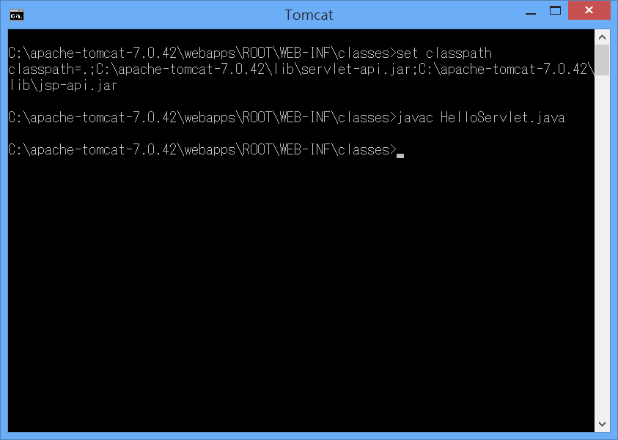
- C:\apache-tomcat-7.0.42\webapps\ROOT 建立一個 FilterIndex.jsp
<%@page contentType="text/html" pageEncoding="UTF-8"%>
<!DOCTYPE html>
<html>
<head>
<meta http-equiv="Content-Type" content="text/html; charset=UTF-8">
<title>JSP Page</title>
<a href=" /FilterDemo">Filter Sample</a><br/>
<a href="/Filter.do">Filter Sample.do</a>
</head>
<body>
<h1>Hello World!</h1>
</body>
</html>
- C:\apache-tomcat-7.0.42\webapps\ROOT\WEB-INF\classes建立一個FilterA.java程式並編譯
import java.io.IOException;
import javax.servlet.Filter;
import javax.servlet.FilterChain;
import javax.servlet.FilterConfig;
import javax.servlet.ServletException;
import javax.servlet.ServletRequest;
import javax.servlet.ServletResponse;
import javax.servlet.annotation.WebFilter;

//@WebFilter(filterName = "FilterA", urlPatterns = {"/FilterDemo"})
public class FilterA implements Filter {

private FilterConfig filterConfig = null;

public void doFilter(ServletRequest request, ServletResponse response, FilterChain chain)
throws IOException, ServletException {
System.out.println("Pre-Process Start");
System.out.println("Pre-Process==>"+filterConfig.getFilterName());
long start=System.currentTimeMillis();
chain.doFilter(request, response);
long end=System.currentTimeMillis();
System.out.println("執行時間:"+(end-start)+"ms");
System.out.println("Post-Process==>"+filterConfig.getFilterName());
System.out.println("=====================================");

}
public void destroy() {
}
public void init(FilterConfig filterConfig) {
this.filterConfig = filterConfig;
if (filterConfig != null) {

}
}

@Override
public String toString() {
if (filterConfig == null) {
return ("FilterA()");
}
StringBuffer sb = new StringBuffer("FilterA(");
sb.append(filterConfig);
sb.append(")");
return (sb.toString());
}
public void log(String msg) {
filterConfig.getServletContext().log(msg);
}
}
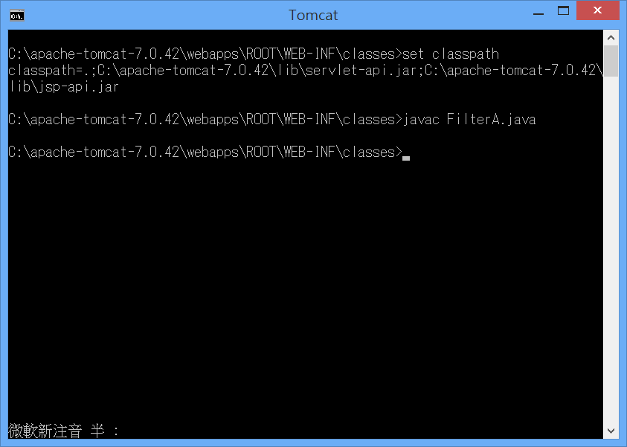
- C:\apache-tomcat-7.0.42\webapps\ROOT\WEB-INF\classes建立一個FilterB.java程式並編譯
import java.io.IOException;
import javax.servlet.Filter;
import javax.servlet.FilterChain;
import javax.servlet.FilterConfig;
import javax.servlet.ServletException;
import javax.servlet.ServletRequest;
import javax.servlet.ServletResponse;
import javax.servlet.annotation.WebFilter;

//@WebFilter(filterName = "FilterB", urlPatterns = {"*.do"})
public class FilterB implements Filter {

private FilterConfig filterConfig = null;

public void doFilter(ServletRequest request, ServletResponse response, FilterChain chain)
throws IOException, ServletException {
System.out.println("Pre:"+filterConfig.getFilterName());
chain.doFilter(request, response);
System.out.println("Post:"+filterConfig.getFilterName()); System.out.println("=====================================");
}
public void destroy() {
}
public void init(FilterConfig filterConfig) {
this.filterConfig = filterConfig;
if (filterConfig != null) {

}
}
@Override
public String toString() {
if (filterConfig == null) {
return ("FilterA()");
}
StringBuffer sb = new StringBuffer("FilterA(");
sb.append(filterConfig);
sb.append(")");
return (sb.toString());
}
public void log(String msg) {
filterConfig.getServletContext().log(msg);
}
}
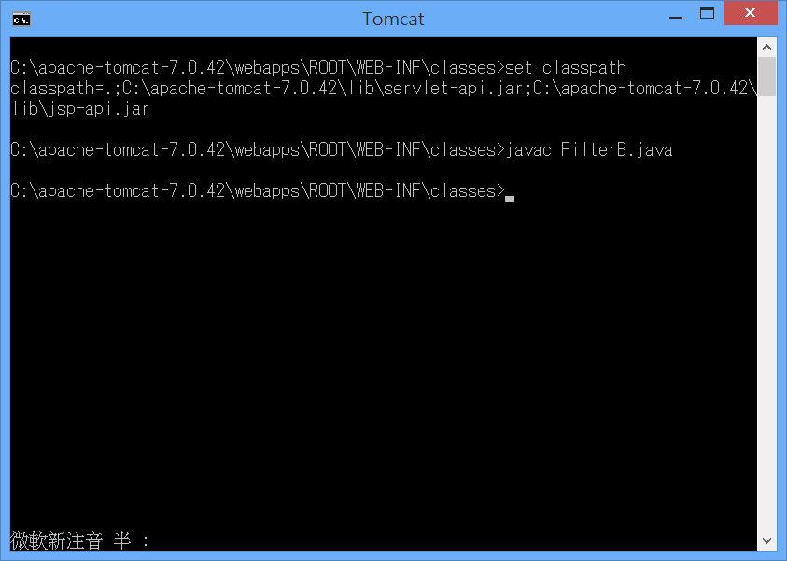
- C:\apache-tomcat-7.0.42\webapps\ROOT\WEB-INF修改web.xml
<filter>
<filter-name>FA</filter-name>
<filter-class>FilterA</filter-class>
</filter>
<filter>
<filter-name>FB</filter-name>
<filter-class>FilterB</filter-class>
</filter>
<filter-mapping>
<filter-name>FA</filter-name>
<url-pattern>*.do</url-pattern>
</filter-mapping>
<filter-mapping>
<filter-name>FB</filter-name>
<url-pattern>/FilterDemo</url-pattern>
</filter-mapping>
<servlet>
<servlet-name>SampleFilter</servlet-name>
<servlet-class>HelloServlet</servlet-class>
</servlet>
<servlet-mapping>
<servlet-name>SampleFilter</servlet-name>
<url-pattern>/FilterDemo</url-pattern>
</servlet-mapping>
<servlet-mapping>
<servlet-name>SampleFilter</servlet-name>
<url-pattern>*.do</url-pattern>
</servlet-mapping>

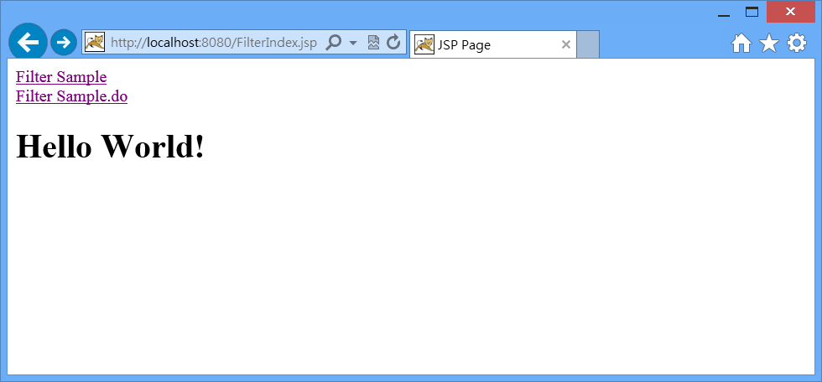

PS>請同學練習如何從NetBeans建立Filter程式

